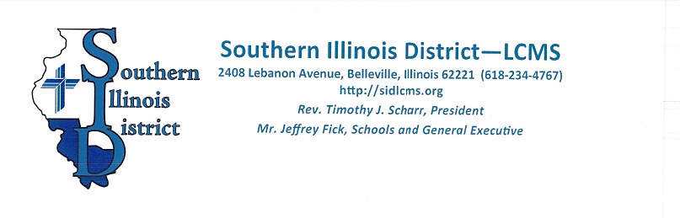
SID Convention Exhibitors

Greetings in the name of Jesus!

Preparations for the Southern Illinois District’s Convention are underway. We will be gathering February 20 - 22, 2025. You are invited to participate in this convention as an exhibitor.

The convention will be held at the Regency Conference Center in O’Fallon, Illinois – adjacent to the Hampton Inn and Hilton Garden Inn. Attendees will include pastors and teachers who serve in the Southern Illinois District, as well as congregational delegates and guests.

Exhibits will be set up in the conference center’s lobby area. (Exhibit space will be limited to the first 30 responders.) A 6-foot skirted table and 1 chair will be provided per table registration. A booth display fee of $100 is requested for the first table, and $50 for each additional table. If needed, electricity will be available for an extra $20. The fee is waived for exhibitors or organizations that provide a convention sponsorship / service or for those representing district sponsored ministries.

The Conference Center will be available Thursday morning for set up, as the convention begins late Thursday afternoon with registration. Opening worship and initial proceedings will take place in the evening. The convention continues all day Friday and through noon on Saturday. Exhibitors will have until 1:30 PM on Saturday to remove their materials.

There are a variety of lodging choices available in the area. Rooms are being held for our group at the adjacent Hilton Garden Inn O’Fallon, IL (618/624-4499) and at the Hampton Inn O’Fallon, IL (618/589-9006). Give our group’s name – Lutheran Church Missouri Synod Southern Illinois District – to get convention rates.

Feel free to contact me with any questions. I look forward to helping you participate in this event. Please complete the EXHIBITOR INFORMATION & REGISTRATION FORM and return it to me by January 22, 2025.

Blessings in Christ,
Donna Kirst

kirstd@holycross-collinsville.org fax (618) 344-1222 work (618) 344-3145 Ext. 211

LCMS Southern Illinois District Convention
The Regency Conference Center, O’Fallon, IL
February 20 – 22, 2025

EXHIBITOR INFORMATION & REGISTRATION (please print)

Name of Organization/Company ___________________________________________

Contact Person _______________________________________

Representative @ Convention ________________________________________

Address _________________________________________________________

City, State, Zip ___________________________________________________

Phone Number _____________________ Fax ________________________

Email _________________________________

I will need _____table(s). $100 for first table, $50 for each additional table

I WILL ______ WILL NOT _____ need electricity. (Electricity access is an additional $20.)

TOTAL AMOUNT DUE ___________ ( Your check made out to “Southern Illinois District” will be due by January 22, 2025.)

I understand that I will need to make my own lodging reservations.

Please send me information on meals available at the Convention. Yes _____. No _____

I will arrive to set up my booth on Thursday at (around) __________am/pm

Is there any other way we can be of service to you? _________________________________________

___________________________________________________________________________________

___________________________________________________________________________________

Please return the above information to:

Donna Kirst
c/o Holy Cross Lutheran School kirstd@holycross-collinsville.org
304 South Street 618-344-1222 (fax)
Collinsville, IL 62234 618/ 344-3145 Ext. 211 (work)

